AI Loan Eligibility Checker
Project Documentation
AI-Powered BFSI Financial Assistance Web Platform

Technology: HTML5 • CSS3 • JavaScript • Claude AI • Google Sheets

Name : Mhd Zahur Rizvi

1. Project Overview
The AI Loan Eligibility Checker is an AI-powered BFSI (Banking, Financial Services and Insurance) web platform designed to simplify and accelerate personal financial decision-making. The platform combines four core financial tools in one interface: Loan Eligibility Checker, Credit Score Analyzer, EMI Calculator, and AI Financial Tips.
The application uses HTML, CSS and JavaScript for the frontend, a dark glassmorphism design for a modern fintech experience, Claude AI for intelligent financial explanations, and Google Sheets for data persistence. The system is intended for educational and estimation purposes and does not replace a bank, credit bureau, or professional financial advisor.
Key features include:
- Instant loan eligibility estimation from user-provided financial information.
- Credit score analysis with understandable categories and improvement suggestions.
- EMI, total interest and total payment calculations.
- AI-generated financial tips and explanations.
- Responsive dashboard for desktop, tablet and mobile devices.
- Google Sheets integration for storing selected application records.
- Demo/fallback mode so core calculations can work without external credentials.

2. Problem Statement
Many individuals find personal financial decisions difficult because loan eligibility criteria, credit scores, EMI calculations and debt-management concepts are often spread across different websites and presented using complex financial terminology. Users may also have difficulty understanding how income, expenses, existing EMIs and credit history affect their borrowing capacity.
The problem is therefore to design a single, simple and interactive platform that can provide quick financial estimates and understandable explanations while clearly communicating that actual lending decisions are made by financial institutions.

3. Objectives
- Develop a centralized web platform containing four useful personal-finance tools.
- Estimate loan eligibility using income, expenses, existing debt, credit score and requested loan details.
- Calculate monthly EMI, total interest and total repayment accurately.
- Explain credit-score factors in simple language.
- Use Claude AI to generate contextual educational financial tips.
- Provide a responsive and professional dashboard using a dark glassmorphism interface.
- Store appropriate user submissions using Google Sheets integration.
- Implement validation, error handling and basic security practices.
- Make the project suitable for academic demonstration, hackathons and portfolio presentation.

4. Proposed Solution
The proposed solution is a browser-based fintech application in which a user enters financial details once and can then access multiple analysis tools. The system validates the input, performs deterministic financial calculations, and optionally sends suitable contextual information to Claude AI for educational explanations.
Module | Purpose | Main Output
Loan Eligibility Checker | Estimate borrowing capacity | Eligibility status, estimated amount, EMI, DTI
Credit Score Analyzer | Explain credit profile | Score category, factors, improvement suggestions
EMI Calculator | Calculate loan repayment | EMI, interest, total payment, amortization
AI Financial Tips | Provide educational guidance | Personalized explanations and practical tips
Dashboard | Present overall financial picture | Income, debt, credit and loan indicators

5. Project Scenarios

Scenario 1: Loan Eligibility
A salaried user enters monthly income, expenses, existing EMI, desired loan amount, tenure, interest rate and credit score. The application estimates disposable income, debt-to-income ratio and the EMI associated with the requested loan, then displays an educational eligibility assessment.

Scenario 2: Credit Score Analysis
A user enters a credit score and supporting factors such as credit utilization, payment history, active loans and recent inquiries. The system categorizes the score and explains which factors can affect the profile.

Scenario 3: EMI Planning
A user enters the principal, annual interest rate and tenure. The calculator displays EMI, total interest, total payment and an amortization schedule.

Scenario 4: AI Financial Assistance
A user asks a financial question such as how to improve credit health or reduce loan burden. Claude AI responds as an educational assistant using the information voluntarily supplied by the user.

Scenario 5: Data Persistence
When configured, relevant non-sensitive application data is submitted to Google Sheets with a timestamp and analysis result. If the external service is unavailable, the application can use a local/demo fallback.

6. System Workflow and Architecture
Overall workflow:

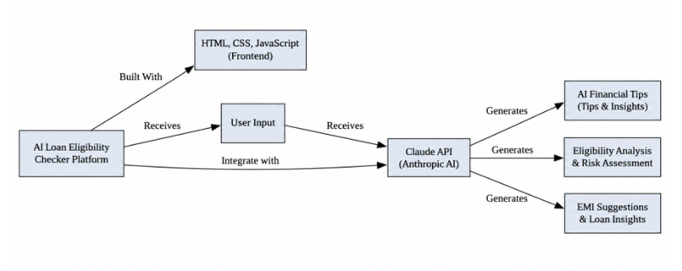

High-Level Architecture
The recommended architecture separates the presentation layer, calculation logic, AI integration and data persistence. API credentials must remain on the server or serverless function and must never be hard-coded into frontend JavaScript.
Layer | Components | Responsibility
Presentation | HTML, CSS, responsive UI | Forms, dashboard, navigation and visual feedback
Application Logic | JavaScript modules | Validation, calculations, state management
AI Layer | Secure Claude API endpoint | Educational financial explanations and tips
Data Layer | Google Sheets/API | Persistence of selected application records
Deployment | Vercel/serverless or suitable host | Production hosting and environment variables

7. Technology Stack
Technology | Use in Project
HTML5 | Semantic structure and forms
CSS3 | Dark glassmorphism interface, responsiveness and animations
JavaScript ES6+ | Calculations, validation, interactions and API communication
Claude AI API | AI-generated educational financial assistance
Google Sheets | Lightweight persistence for selected records
Node.js/Serverless API | Secure proxy/API endpoints where required
Git/GitHub | Version control and source-code management
Vercel | Deployment of the web application/API functions

The architecture can remain lightweight because the deterministic financial calculations do not require a machine-learning model. AI is used primarily for natural-language explanation and personalized educational tips.

8. Database Design
For a lightweight academic implementation, Google Sheets acts as the persistence layer rather than a traditional relational database. Each row represents one analysis/submission.
Field | Example | Purpose
Timestamp | 2026-09-30 18:30 | Record creation time
Name | Demo User | User identification when voluntarily provided
Age | 25 | Eligibility input
Employment Type | Salaried | Financial profile
Monthly Income | 50000 | Income input
Monthly Expenses | 20000 | Expense input
Existing EMI | 5000 | Current debt obligation
Loan Amount | 500000 | Requested loan amount
Tenure | 60 months | Loan duration
Credit Score | 750 | Credit profile input
Estimated EMI | 10624 | Calculated repayment
Eligibility Result | Potentially Eligible | Estimated outcome

Security consideration: unnecessary sensitive information should not be stored. Google credentials and service-account keys must remain server-side or in protected environment variables.

9. Financial Calculations and AI Logic

9.1 EMI Calculation
The application uses the standard reducing-balance EMI formula:
EMI = P × R × (1 + R)^N / ((1 + R)^N − 1)
- P = principal loan amount.
- R = monthly interest rate = annual interest rate / (12 × 100).
- N = total number of monthly installments.

9.2 Total Payment
Total Payment = EMI × Number of Months

9.3 Total Interest
Total Interest = Total Payment − Principal

9.4 Debt-to-Income Ratio
A simple project-level DTI indicator can be calculated as: DTI = (Existing EMI + New EMI) / Monthly Income × 100. The result should be treated as an estimate rather than a universal lending rule.

9.5 Loan Eligibility Logic
The system can combine disposable income, DTI, credit score and requested loan characteristics into a transparent rule-based assessment. Example factors include whether income is positive, whether the estimated new EMI leaves reasonable disposable income, and whether the entered credit score falls within the valid range.

9.6 AI Logic
Claude AI receives only the context necessary to answer the user's question. The system prompt should require the AI to behave as an educational financial assistant, explain uncertainty, avoid guaranteed approval claims, avoid pretending to be a lender or credit bureau, and provide understandable guidance.

10. Frontend and Dashboard
The frontend is designed around a dark glassmorphism fintech aesthetic. The interface uses glass cards, rounded panels, subtle borders, gradients, responsive grids and restrained animations.
- Responsive navigation bar with links to all four tools.
- Hero section with clear call-to-action buttons.
- Four feature cards for the main financial tools.
- Interactive forms with validation messages.
- Result cards showing key financial indicators.
- Credit-score meter and financial-health indicators.
- EMI summary and principal-versus-interest visualization.
- AI chat-style panel with typing/loading feedback.
- Demo data button for easy project demonstration.
- Mobile-friendly layout with touch-friendly controls.

Dashboard Indicators
Indicator | Displayed Information
Income | Monthly income
Expenses | Monthly expenses
Existing Debt | Existing EMI and obligations
Credit | Credit score and category
Loan | Estimated eligibility and requested amount
EMI | Estimated monthly installment
Financial Health | Simple visual indicators based on entered data

11. Testing and Deployment

11.1 Testing Strategy
Test Area | Example Test | Expected Result
Form Validation | Leave income empty | Validation message displayed
Credit Score | Enter 750 | Score categorized correctly
EMI | Enter valid loan data | Correct EMI calculated
Invalid Input | Credit score = 1000 | Input rejected
AI Failure | Simulate API timeout | Friendly fallback/error shown
Sheets Failure | Disable data endpoint | App remains usable in fallback mode
Responsive UI | Open on mobile | Layout adapts to screen size
Security | Inspect frontend for secrets | No API credentials exposed
Browser Console | Run full flow | No unexpected errors

11.2 Deployment
- Create a Git repository and push the project source code.
- Configure environment variables for Claude and Google Sheets credentials.
- Deploy the frontend and serverless/API functions to a suitable host such as Vercel.
- Test production URLs and all core features.
- Verify that credentials are not included in the Git repository.
- Document setup and deployment steps in README.md.
A .env.example file should list variable names without real secret values. A .gitignore file should exclude environment files and credential files.

12. Screenshots, GitHub and Demo

12.1 Recommended Screenshots
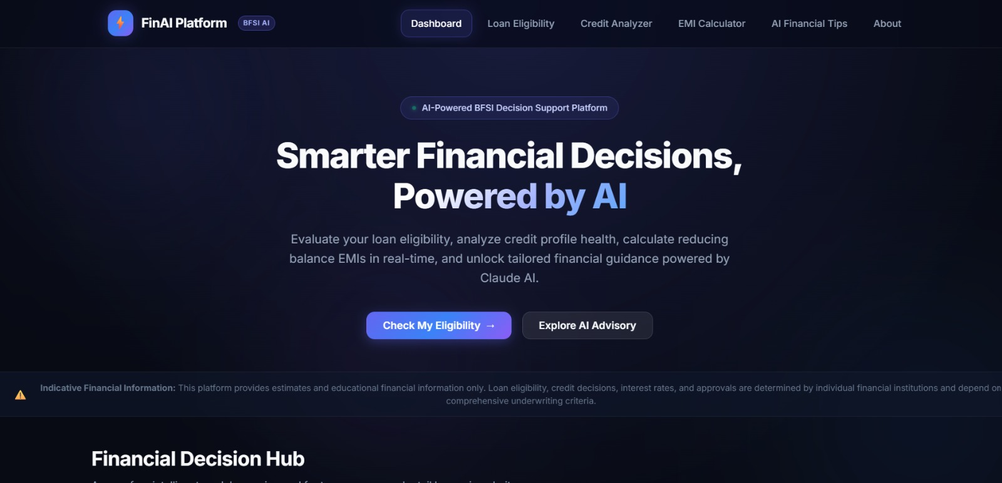

12.2 GitHub Presentation
The GitHub repository should contain a clear README, project screenshots, feature list, technology stack, installation instructions, environment-variable documentation, architecture description and deployment link.
Github repository Link :- https://github.com/syedxzahur/AI-Loan-Eligibility-Checker

12.3 Live Demo
During the demonstration, start with the Home page, use the demo-data button, perform an EMI calculation, run a loan eligibility estimate, analyze a credit score, and finally ask Claude AI a financial question. Explain the calculation logic and show the dashboard and persistence workflow.
Demo link :- https://drive.google.com/file/d/1pvVy3E5BEBrdxMk_XDD7AOK3vPYWpMgH/view?pli=1

13. Conclusion and Future Enhancements

13.1 Conclusion
The AI Loan Eligibility Checker demonstrates how web development, financial calculations, AI assistance and cloud-based data persistence can be combined into a single BFSI application. The project provides four practical financial tools through an accessible interface and uses AI to make financial concepts easier to understand.
The system is primarily an educational and estimation platform. Actual loan approval, interest rates, credit decisions and financial outcomes depend on individual banks, lenders and credit-information providers.

13.2 Future Enhancements
- Integration with verified banking and financial APIs.
- Real-time credit-bureau integration where legally and technically permitted.
- Comparison of multiple loan products and lenders.
- Expense tracking and automated budgeting.
- Personal financial planning and goal tracking.
- Advanced AI financial assistant with stronger personalization controls.
- Financial document analysis for uploaded statements.
- Fraud and anomaly detection features.
- Multilingual support for Indian languages.
- Voice-based financial assistant.
- Dedicated Android/iOS mobile application.
- More advanced analytics and financial-health reporting.

Important Project Disclaimer
This platform provides estimates and educational financial information based on user-provided data. It does not guarantee loan approval, credit outcomes, interest rates or financial returns. Actual eligibility, approval decisions and terms are determined by individual banks or financial institutions. Users should verify important financial decisions with appropriate official sources or qualified professionals.

